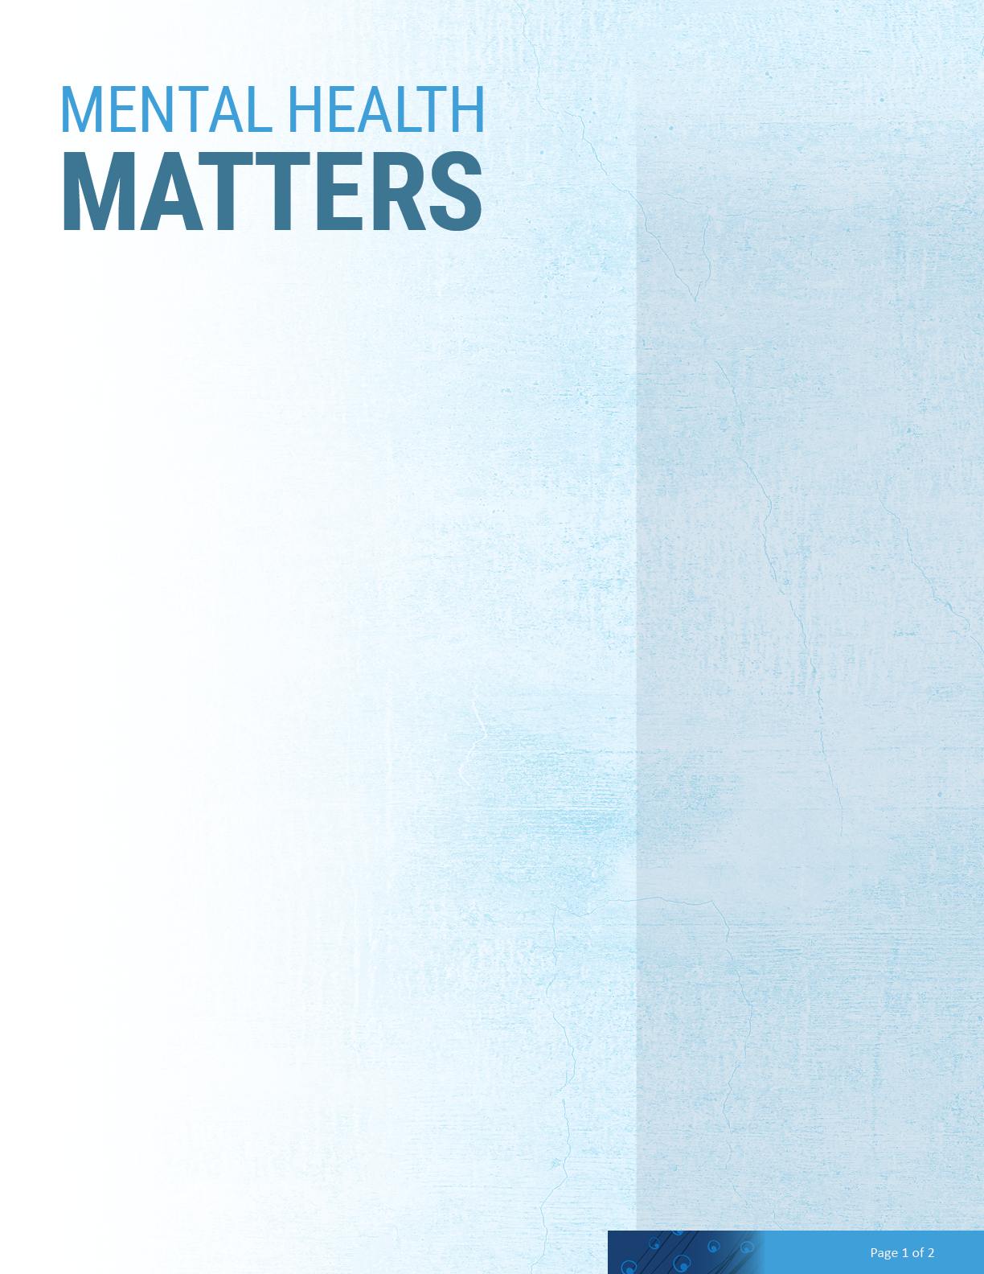

**Mental Health Statistics**

Millions of people in the U.S. are affected by mental illness each year. It’s important to measure how common mental illness is, so we can understand its physical, social, and financial impact — and so we can show that no one is alone. These numbers are also powerful tools for raising public awareness and advocating for better healthcare.

• **1 in 5 U.S. adults** experience mental illness each year

• **1 in 6 U.S. youth ages 6-17** experience a mental health disorder each year

• **50%** of all life-time mental illness **begins by age 14** and **75% by age 24**

• Suicide is the **second leading cause of death** among people aged **10-34**

• At least **8.4 million** people in the U.S. **provide care** to an adult with a mental or emotional health issue

• Caregivers of adults with mental or emotional health issues spend an **average of 32 hours per week** providing unpaid care

• Around **65%** of people experiencing symptoms of mental illness **don’t seek help from health services.**

• Across the U.S. economy, serious mental illness causes **$193.2 billion in lost earnings** each year

**About Mental Health Conditions**

A mental illness is a condition that affects a person’s thinking, feeling or mood. Such conditions may affect someone’s ability to relate to others and function each day. Each person will have different experiences, even people with the same diagnosis.

A mental health condition isn’t the result of one event. Research suggests multiple overlapping causes, which can include

• Genetics

• Environment

• Lifestyle, unhealthy habits

• A stressful job or home life

• Traumatic life events

• Brain chemistry

• Negative thoughts

**A Brief Guide for HR and Managers**

# Common Mental Health Conditions

ADHD – a developmental disorder where there are significant problems with attention, hyperactivity or acting impulsively.

Anxiety – everyone experiences some anxiety, but when it becomes overwhelming and starts to repeatedly impact a person’s life, it may be an anxiety disorder.

Bipolar Disorder – causes dramatic highs and lows in a person’s mood, energy and ability to think clearly.

Depression – more than just feeling sad or going through a rough patch, depression is a serious mental health condition that impacts day-to-day functioning.

Eating Disorders – characterized by a preoccupation with food and weight that makes it hard to focus on other aspects of one’s life.

Obsessive-Compulsive Disorder – causes repetitive, unwanted or intrusive thoughts (obsessions) and irrational, excessive urges to engage in certain actions (compulsions).

Post-Traumatic Stress Disorder (PTSD) – is the result of traumatic events, such as military combat, assault, an accident or natural disaster.

Schizophrenia – causes people to lose touch with reality, often in the form of hallucinations, delusions and extremely disordered thinking and behavior.

Source: NAMI. Mental Health By the Numbers. (Last updated February 2022}. Retrieved from: https://[www.nami.org/mhstats](http://www.nami.org/mhstats)

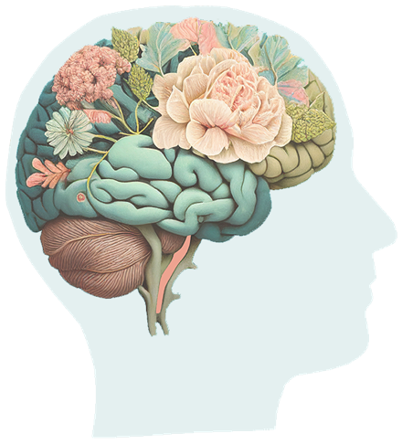

# Signs and Symptoms

Recognizing mental illness can be challenging in that each condition has its own symptoms, and sometimes thoughts and behaviors may be the result of a physical illness. That said, common signs of mental illness include:

• Feeling very sad or withdrawn for more than two weeks

• Intense worries or fears that get in the way of daily activities

• Confused thinking or problems concentrating, learning, or staying still

• Extreme or drastic changes in mood, behavior, or personality

• Avoiding social activities

• Difficulties understanding or relating to other people

• Changes in sleeping habits or feeling tired and low energy

• Changes in eating habits such as increased hunger or lack of appetite

• Difficulty perceiving reality (delusions or hallucinations, in which a person experiences and senses things that don’t exist in objective reality)

• Excessive use of substances like alcohol or drugs

• Multiple physical ailments without obvious causes (such as headaches, stomach aches, vague and ongoing “aches and pains”)

• Severe, out-of-control risk-taking behavior that causes harm to self or others

• Trying to harm or end one’s life or making plans to do so

# JHEAP 888-978-1262 | www.myccaonline.com

**Mental Health in the Workplace**

Some ways a mental health condition may impact or manifest in the workplace include:

• Increase in overall sick leave

• Reduction in productivity and output

• Deterioration in planning and time management

• Loss of motivation and commitment

• Poor relationships with clients, coworkers

• Increase in disciplinary problems

• Increase in error rates

• Poor decision making

When addressing signs of poor mental health with a colleague, keep in mind the following DOs and DON’Ts

**Do**

• Open the dialogue and create a safe space for sharing

- I’ve noticed you’re_______ (coming in late, eating less, avoiding social situations, less talkative during team meetings, etc.)

- What can I do to support you?

• Try to understand what they’re experiencing and how their daily life is impacted

• Offer support, compassion and hope

• Stress the importance of putting health first

• Seek consultation and support from your Johns Hopkins Employee Assistance Program—JHEAP

• Take mental health concerns seriously, especially if there is talk of harm to self or others

- Notify a manager and/or HR

- Call JHEAP to do a risk assessment

- Call emergency services

**Don’t**

• Don’t diagnose

• Don’t stigmatize

• Never ignore or minimize comments about suicide or other mental health concerns

**Benefits of Seeking Support**

You don’t have to be extremely sick to get help. If you think there’s even a slight chance you need help with your mental health, talk to your doctor. The earlier you seek help, the better the prospects for recovery, and the sooner you’ll be on the road to better health.

Most people with a mental illness recover well and are able to function independently in the community with appropriate, ongoing treatment and support. Effective types of treatment include a combination of talk therapy, medication, community support, and self-care. It’s important to note that treatment is not one-size-fits-all. People often try different combinations before settling on what’s best for them.