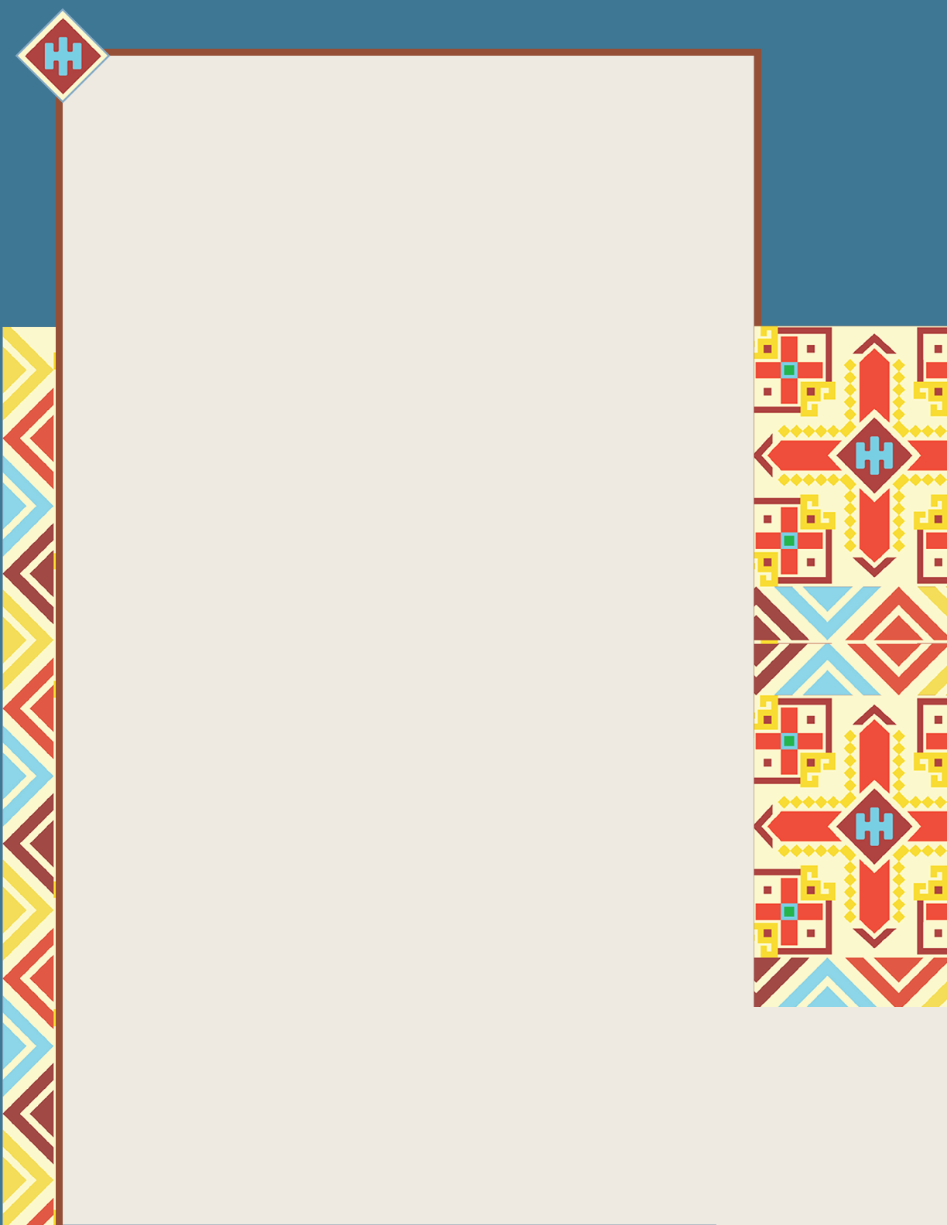
MENTAL HEALTH RESOURCES
FOR NATIVE AND INDIGENOUS COMMUNITIES
In addition to support from JHEAP, there are a number of the mental health resources available specifically for Native Americans, Alaska Natives, and Native Hawaiians.

Center for Native American Youth (CNAY): A national advocacy organization working to improve the health, safety, and overall wellbeing of Native American youth ages 24 and under

Child Welfare Information Gateway: Resources to engage American Indian families around mental health and wellbeing

Indian Health Service:
Provides a comprehensive health service delivery system for approximately 2.6 million American Indians and Alaska Natives who belong to 574 federally recognized tribes.
- Division of Behavioral Health responsible for efforts to monitor, treat, and prevent mental and behavioral health conditions and substance use
- Mental Health resources and programs
- Telebehavioral Health list of sites offering culturally sensitive health services

Indigenous Story Studio:
creates illustrations, posters, videos, and comic books on health and social issues for youth
  - Strength of the Sash and
Tomorrow’s Hope suicide prevention
  - Making it Right community justice, policing
  - Just a Story mental health stigma

Native Hope: Dedicated to addressing injustice, healing from violence and trauma, and inspiring hope through storytelling and impactful programs
Note: The resources included here are not endorsed by JHEAP, and JHEAP is not responsible for the content of, or service provided by, these resources.

One Sky Center: The American Indian and Alaska Native National Resource Center for Health, Education, and Research, works to improve prevention and treatment of mental health and substance use problems and services among Native people

StrongHearts Native Helpline or
1-844-762-8483: 24/7, safe, and anonymous support for Native Americans and Alaska Natives, offering culturally appropriate support and advocacy to those experiencing domestic and sexual violence

WeRNative: a comprehensive health resource for Native youth by Native youth, promoting holistic health and positive growth in local communities and nation at large
- My Culture Traditions, Identity
- My Life and My Mind Building Mental Resilience, Mental Health Challenges, Getting Help, and more
- My Relationships Relationships and Dating, Sexual Health
- Ask Auntie similar to an advice column, search for questions similar to yours, and if you don’t find answers, Auntie Amanda will reply to questions and notify you when answers are posted

